ASSIGMENT #3

Q#1

#include<iostream>

using namespace std;

int main()

{

int size;

cout << "enter size of triangle :";

cin >> size;

for (int i = 1; i <= size; i++)

{

for (int j = 1; j <= i; j++)

cout << "\*";

cout << endl;

}

system("pause");

return 0;

}

OUTPUT

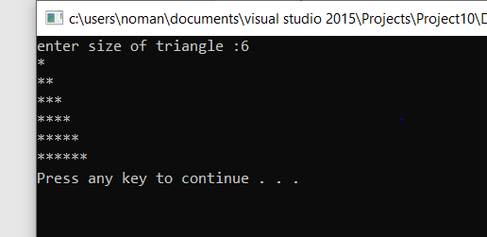

Q #2

Code:

#include<iostream>

using namespace std;

int main()

{

int size;

cout << "enter size of triangle :";

cin >> size;

for (int i=1; i <= size; i++)

{

for (int j = i; j <=size; j++)

cout << "\*";

cout << endl;

}

system("pause");

return 0;

}

Output

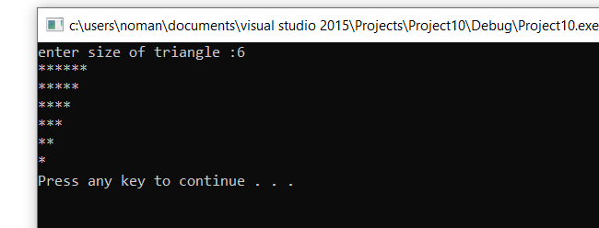

QUESTION #12

Code

#include<iostream>

using namespace std;

int main()

{

char grade;

cout << "Enter grade : ";

cin >> grade;

switch (grade)

{

case 'A':

cout << "EXCELLENT : ";

break;

case 'B':

cout << "GOOD : ";

break;

case 'C':

cout << "AVERAGE : ";

break;

case 'D':

cout << "poor : ";

break;

case 'F':

cout << "fail : AA";

break;

default:

cout << "Invalid input ";

}

system("pause");

return 0;

}

OUTPUT

